**Deploy Three-Tier Architecture in**

**AWS using Terraform**

* **What is Terraform?**

Terraform is an open-source infrastructure as a code (IAC) tool that allows to create, manage & deploy the production-ready environment. Terraform codifies cloud APIs into declarative configuration files. Terraform can manage both existing service providers and custom in-house solutions.

* In this project, we will deploy a three-tier application in AWS using Terraform.



* **Prerequisites:**
* Basic knowledge of AWS & Terraform
* AWS Account
* IAM User
* GitHub Account
* AWS Access & Secret Key
* **Procedure:**
* Launch a EC2 instance using amazon Linux 2 image and give SSH access to it.

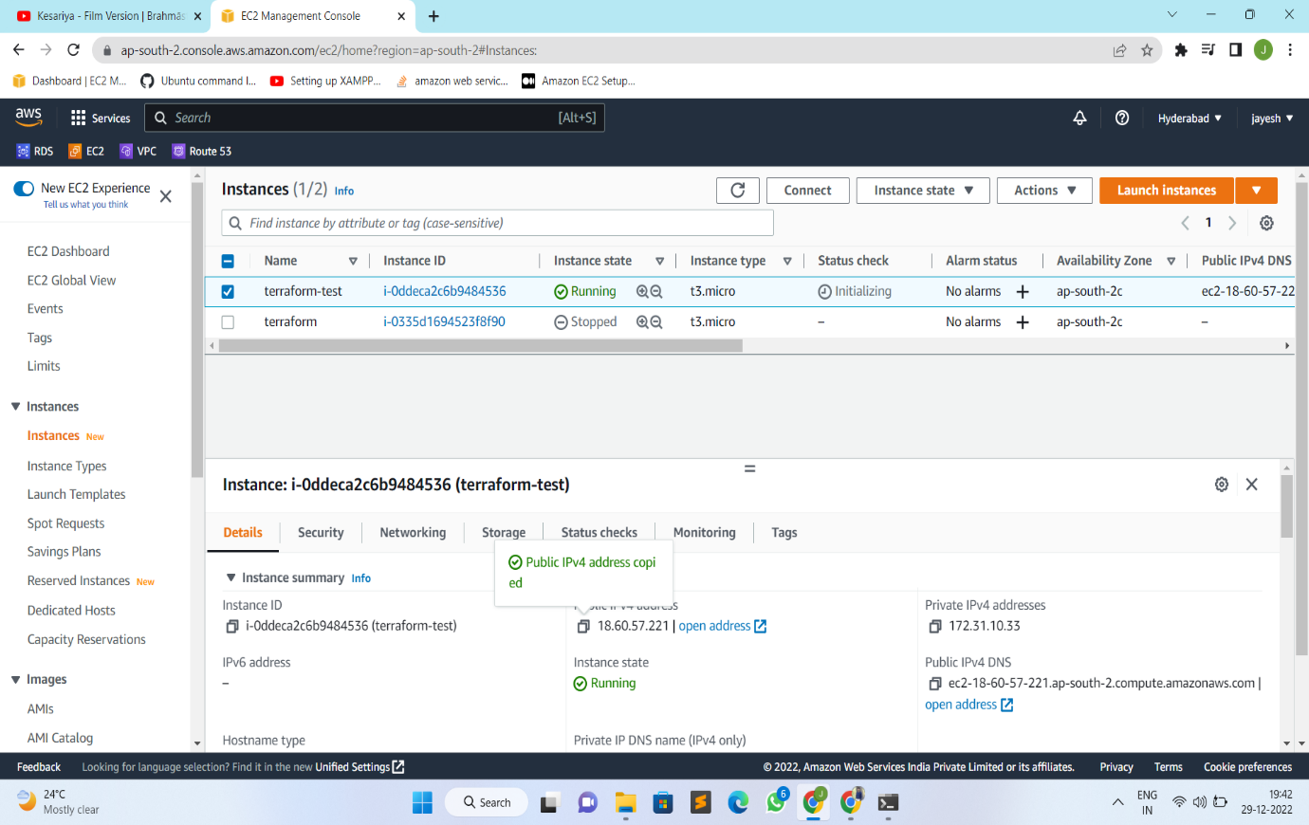

* Connect the instance through SSH using terminal.

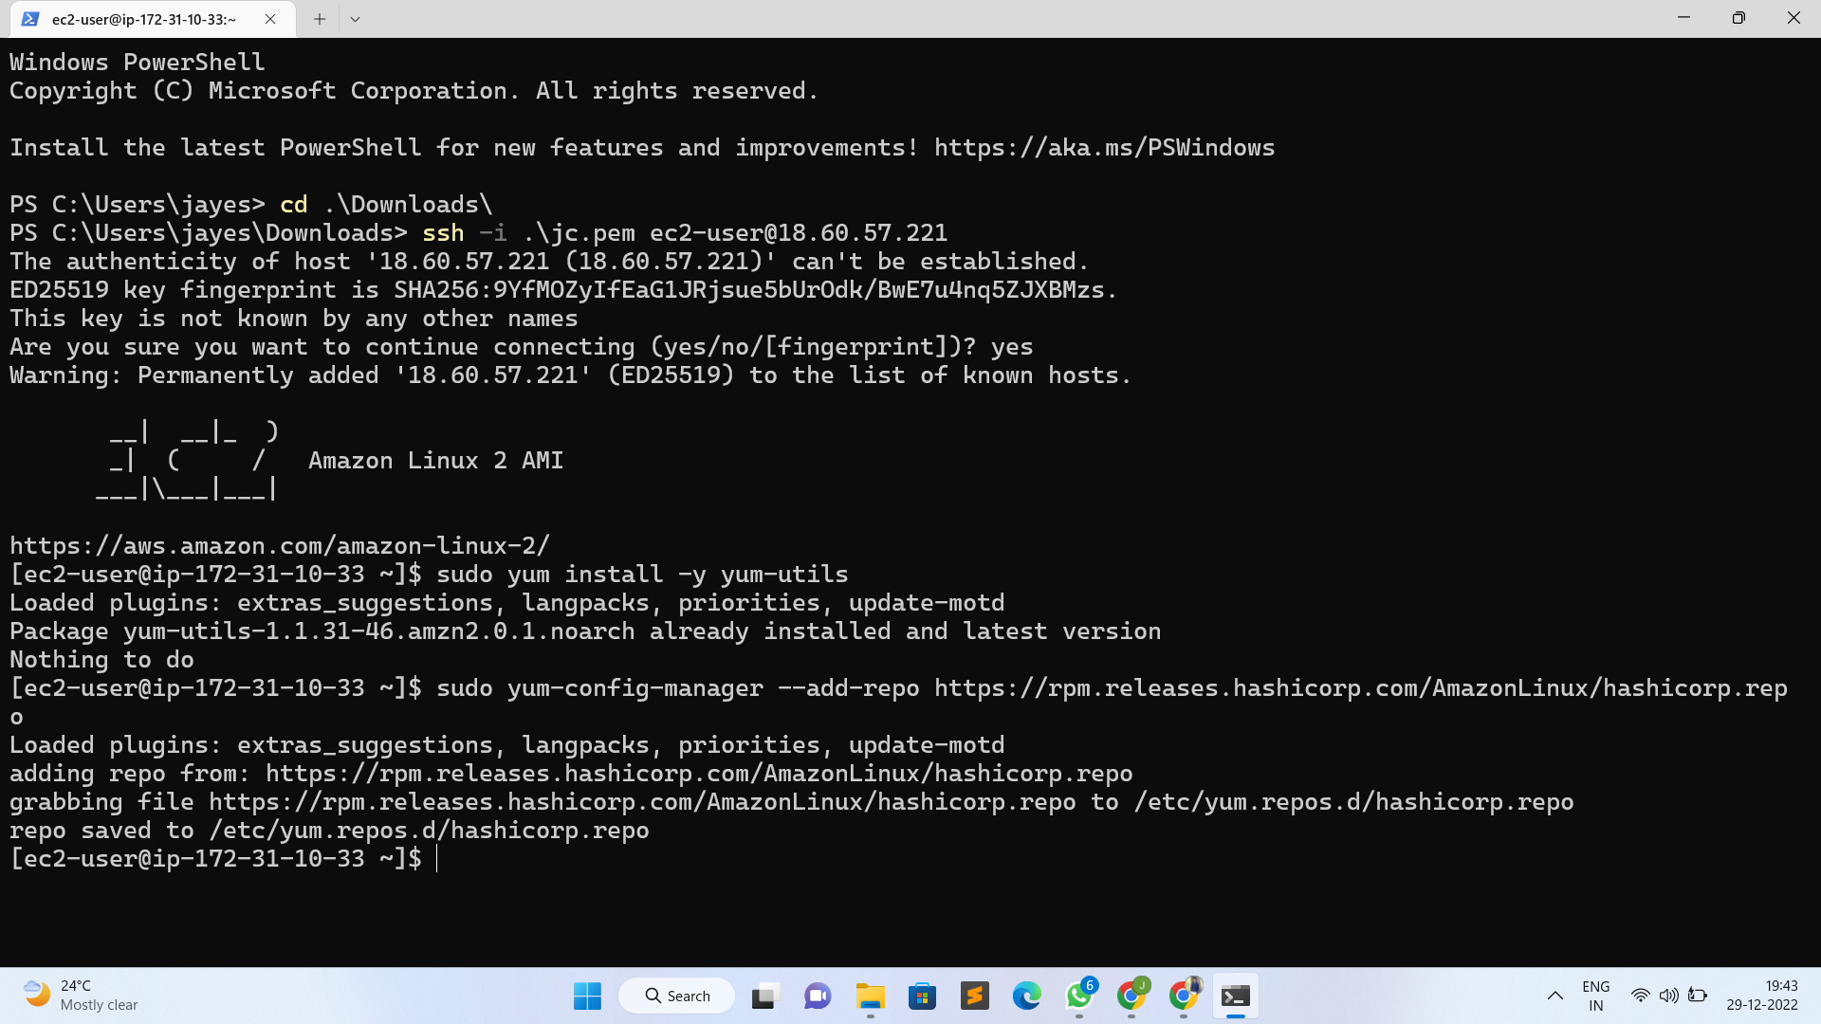

* Install Terraform in the Instance using the below commands:
* sudo yum -y install yum-utils



* sudo yum-config-manager –add-repo <https://rpm.releases.hashicorp.com/amazonLinux/hashicorp.repo>



* sudo yum -y install terraform

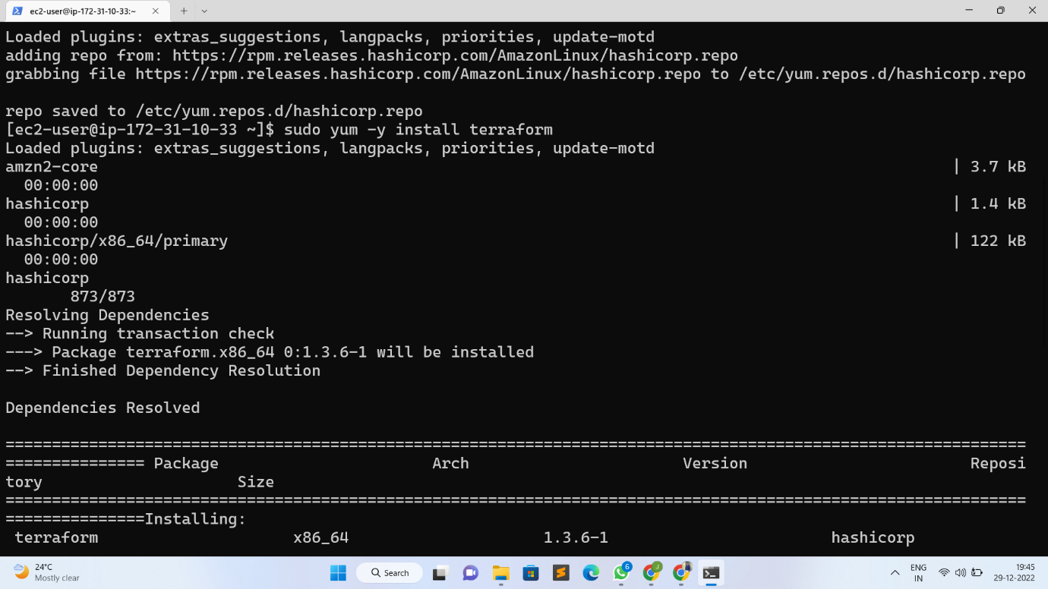

* Create terraform files of requirements that we want to create.

**Step 1: Create a file for the VPC**

* Create vpc.tf file and add the below code to it

# Creating VPC

resource "aws_vpc" "demovpc" {

cidr_block = "${var.vpc_cidr}"

instance_tenancy = "default"

tags = {

Name = "Demo VPC"

}

}

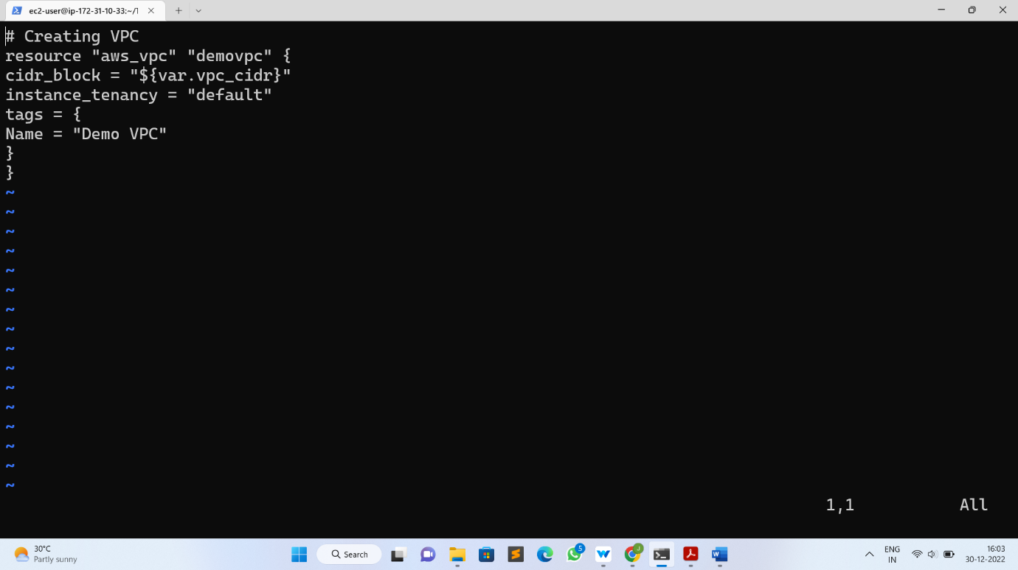

**Step 2: Create a file for the Subnet**

* For this project, we will create total 6 subnets for the front-end tier and back-end tier with a mixture of public & private subnet.
* Create subnet.tf file and add the below code to it

# Creating 1st web subnet

resource "aws_subnet" "public-subnet-1" {

vpc_id = "${aws_vpc.demovpc.id}"

cidr_block = "${var.subnet_cidr}"

map_public_ip_on_launch = true

availability_zone = "us-east-1a"

tags = {

Name = "Web Subnet 1"

}

}

# Creating 2nd web subnet

resource "aws_subnet" "public-subnet-2" {

vpc_id = "${aws_vpc.demovpc.id}"

cidr_block = "${var.subnet1_cidr}"

map_public_ip_on_launch = true

availability_zone = "us-east-1b"

tags = {

Name = "Web Subnet 2"

}

}

# Creating 1st application subnet

resource "aws_subnet" "application-subnet-1" {

vpc_id = "${aws_vpc.demovpc.id}"

cidr_block = "${var.subnet2_cidr}"

map_public_ip_on_launch = false

availability_zone = "us-east-1a"

tags = {

Name = "Application Subnet 1"

}

}

# Creating 2nd application subnet

resource "aws_subnet" "application-subnet-2" {

vpc_id = "${aws_vpc.demovpc.id}"

cidr_block = "${var.subnet3_cidr}"

map_public_ip_on_launch = false

availability_zone = "us-east-1b"

tags = {

Name = "Application Subnet 2"

}

}

# Create Database Private Subnet

resource "aws_subnet" "database-subnet-1" {

vpc_id = "${aws_vpc.demovpc.id}"

cidr_block = "${var.subnet4_cidr}"

availability_zone = "us-east-1a"

tags = {

Name = "Database Subnet 1"

}

}

# Create Database Private Subnet

resource "aws_subnet" "database-subnet-2" {

vpc_id = "${aws_vpc.demovpc.id}"

cidr_block = "${var.subnet5_cidr}"

availability_zone = "us-east-1a"

tags = {

Name = "Database Subnet 1"

}

}

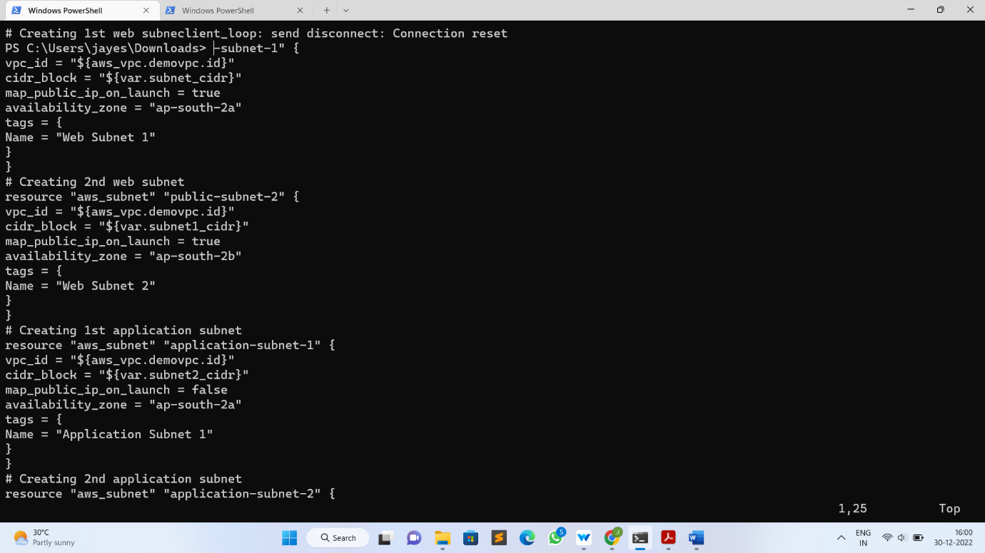

**Step 3: Create a file for the Internet Gateway**

* Create igw.tf file and add the below code to it

# Creating Internet Gateway

resource "aws_internet_gateway" "demogateway" {

vpc_id = "${aws_vpc.demovpc.id}"

}

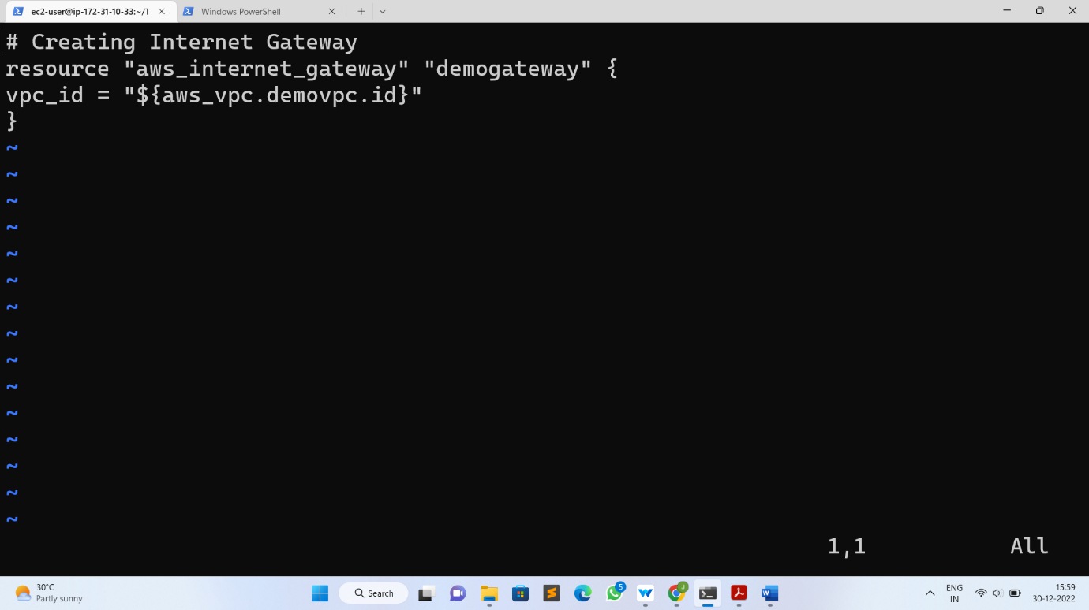

**Step 4: Create a file for the Route table**

* Create route_table_public.tf file and add the below code to it

# Creating Route Table

resource "aws_route_table" "route" {

vpc_id = "${aws_vpc.demovpc.id}"

route {

cidr_block = "0.0.0.0/0"

gateway_id = "${aws_internet_gateway.demogateway.id}"

}

tags = {

Name = "Route to internet"

}

}

# Associating Route Table

resource "aws_route_table_association" "rt1" {

subnet_id = "${aws_subnet.demosubnet.id}"

route_table_id = "${aws_route_table.route.id}"

}

# Associating Route Table

resource "aws_route_table_association" "rt2" {

subnet_id = "${aws_subnet.demosubnet1.id}"

route_table_id = "${aws_route_table.route.id}"

}

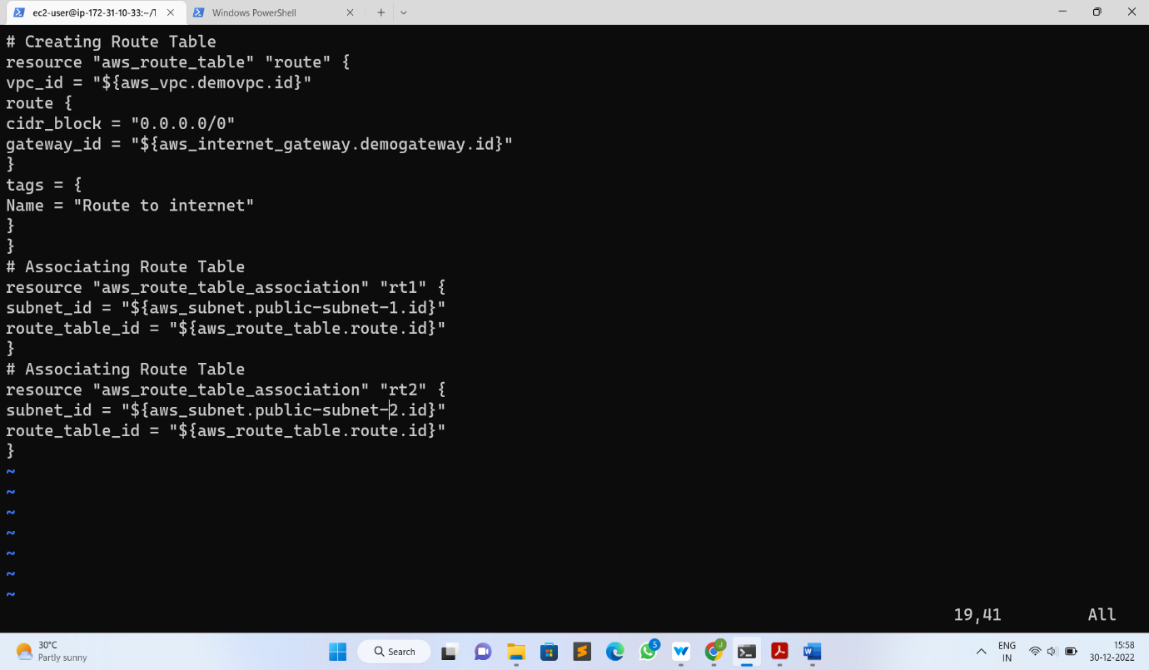

* In the above code, we are creating a new route table and forwarding all the requests to the 0.0.0.0/0 CIDR block.
* we also attaching this route table to the subnet created earlier. So, it will work as the Public Subnet

**Step 5: Create a file for EC2 instances**

* Create ec2.tf file and add the below code to it

# Creating 1st EC2 instance in Public Subnet

resource "aws_instance" "demoinstance" {

ami = "ami-087c17d1fe0178315"

instance_type = "t2.micro"

count = 1

key_name = "tests"

vpc_security_group_ids = ["${aws_security_group.demosg.id}"]

subnet_id = "${aws_subnet.demoinstance.id}"

associate_public_ip_address = true

user_data = "${file("data.sh")}"

tags = {

Name = "My Public Instance"

}

}

# Creating 2nd EC2 instance in Public Subnet

resource "aws_instance" "demoinstance1" {

ami = "ami-087c17d1fe0178315"

instance_type = "t2.micro"

count = 1

key_name = "tests"

vpc_security_group_ids = ["${aws_security_group.demosg.id}"]

subnet_id = "${aws_subnet.demoinstance.id}"

associate_public_ip_address = true

user_data = "${file("data.sh")}"

tags = {

Name = "My Public Instance 2"

}

}

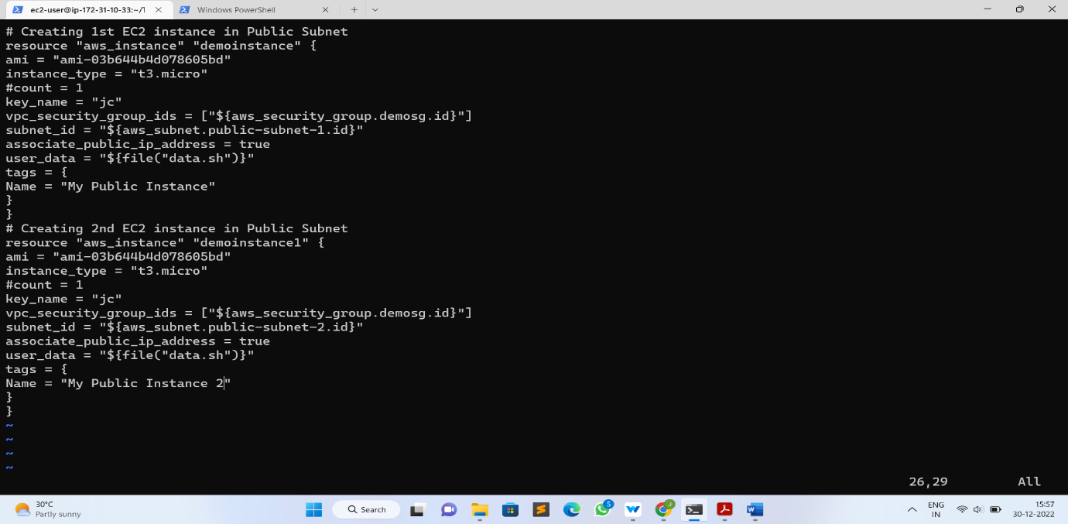

* We will use the userdata to configure the EC2 instance, we will discuss data.sh file later

**Step 6: Create a file for Security Group for the Frontend tier**

* Create web_sg.tf file and add the below code to it

# Creating Security Group

resource "aws_security_group" "demosg" {

vpc_id = "${aws_vpc.demovpc.id}"

# Inbound Rules

# HTTP access from anywhere

ingress {

from_port = 80

to_port = 80

protocol = "tcp"

cidr_blocks = ["0.0.0.0/0"]

}

# HTTPS access from anywhere

ingress {

from_port = 443

to_port = 443

protocol = "tcp"

cidr_blocks = ["0.0.0.0/0"]

}

# SSH access from anywhere

ingress {

from_port = 22

to_port = 22

protocol = "tcp"

cidr_blocks = ["0.0.0.0/0"]

}

# Outbound Rules

# Internet access to anywhere

egress {

from_port = 0

to_port = 0

protocol = "-1"

cidr_blocks = ["0.0.0.0/0"]

}

tags = {

Name = "Web SG"

}

}

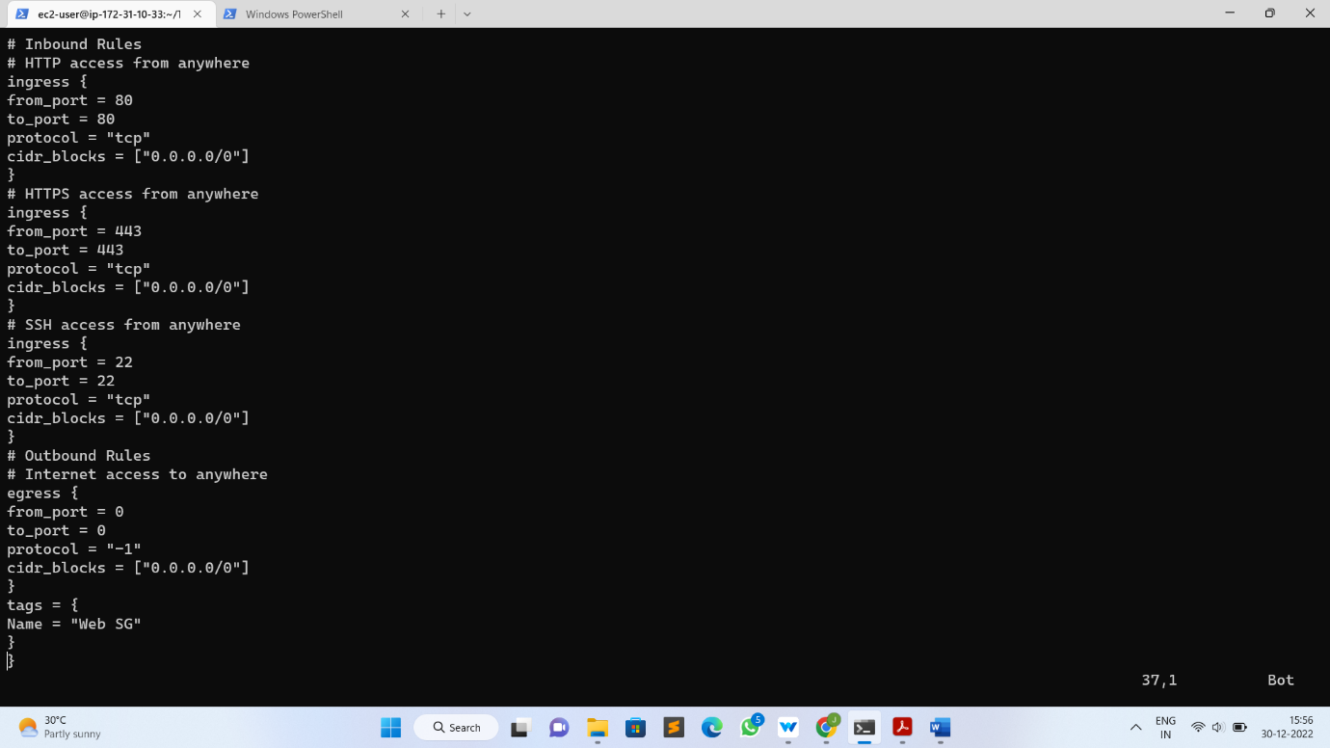

* Here, we opened 80,443 & 22 ports for the inbound connection and we are opened all the ports for the outbound connection

**Step 7: Create a file for Security Group for the Database tier**

* Create database_sg.tf file and add the below code to it

# Create Database Security Group

resource "aws_security_group" "database-sg" {

name = "Database SG"

description = "Allow inbound traffic from application layer"

vpc_id = aws_vpc.demovpc.id

ingress {

description = "Allow traffic from application layer"

from_port = 3306

to_port = 3306

protocol = "tcp"

security_groups = [aws_security_group.demosg.id]

}

egress {

from_port = 32768

to_port = 65535

protocol = "tcp"

cidr_blocks = ["0.0.0.0/0"]

}

tags = {

Name = "Database SG"

}

}

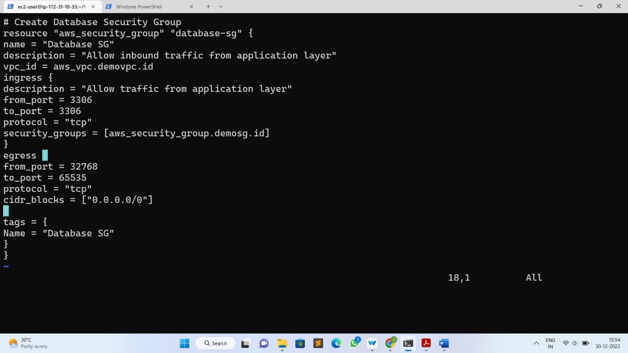

* We opened 3306 ports for the inbound connection and We are opened all the ports for the outbound connection.

**Step 8: Create a file Application Load Balancer**

* Create alb.tf file and add the below code to it

# Creating External LoadBalancer

resource "aws_lb" "external-alb" {

name = "External LB"

internal = false

load_balancer_type = "application"

security_groups = [aws_security_group.demosg.id]

subnets = [aws_subnet.public-subnet-1.id, aws_subnet.public-subnet-1.id]

}

resource "aws_lb_target_group" "target-elb" {

name = "ALB TG"

port = 80

protocol = "HTTP"

vpc_id = aws_vpc.demovpc.id

}

resource "aws_lb_target_group_attachment" "attachment" {

target_group_arn = aws_lb_target_group.external-alb.arn

target_id = aws_instance.demoinstance.id

port = 80

depends_on = [

aws_instance.demoinstance,

]

}

resource "aws_lb_target_group_attachment" "attachment" {

target_group_arn = aws_lb_target_group.external-alb.arn

target_id = aws_instance.demoinstance1.id

port = 80

depends_on = [

aws_instance.demoinstance1,

]

}

resource "aws_lb_listener" "external-elb" {

load_balancer_arn = aws_lb.external-alb.arn

port = "80"

protocol = "HTTP"

default_action {

type = "forward"

target_group_arn = aws_lb_target_group.external-alb.arn

}

}

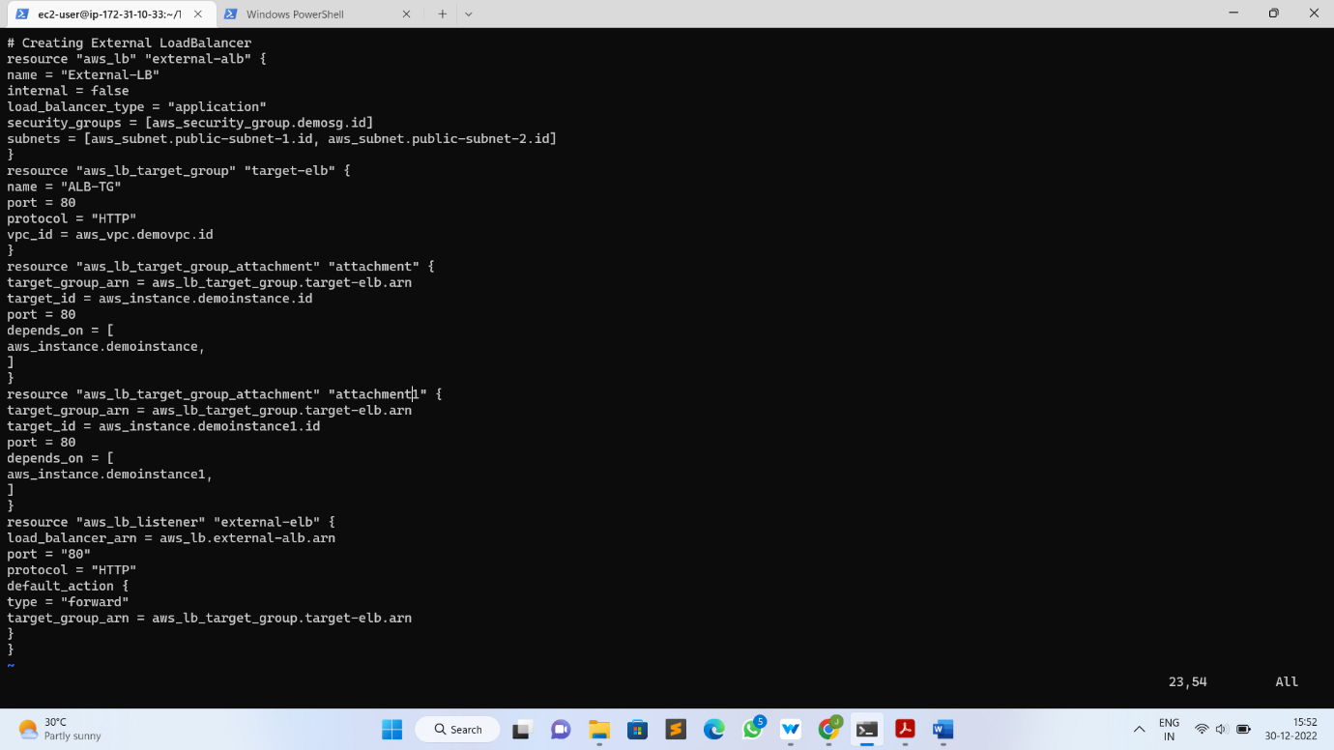

* The above load balancer is of type external
* Load balancer type is set to application
* The aws_lb_target_group_attachment resource will attach our instances to the Target Group.
* The load balancer will listen requests on port 80

**Step 9: Create a file for the RDS instance**

* Create a rds.tf file and add the below code to it

# Creating RDS Instance

resource "aws_db_subnet_group" "default" {

name = "main"

subnet_ids = [aws_subnet.database-subnet-1.id, aws_subnet.database-subnet-1.id]

tags = {

Name = "My DB subnet group"

}

}

resource "aws_db_instance" "default" {

allocated_storage = 10

db_subnet_group_name = aws_db_subnet_group.default.id

engine = "mysql"

engine_version = "8.0.20"

instance_class = "db.t2.micro"

multi_az = true

name = "mydb"

username = "username"

password = "password"

skip_final_snapshot = true

vpc_security_group_ids = [aws_security_group.database-sg.id]

}

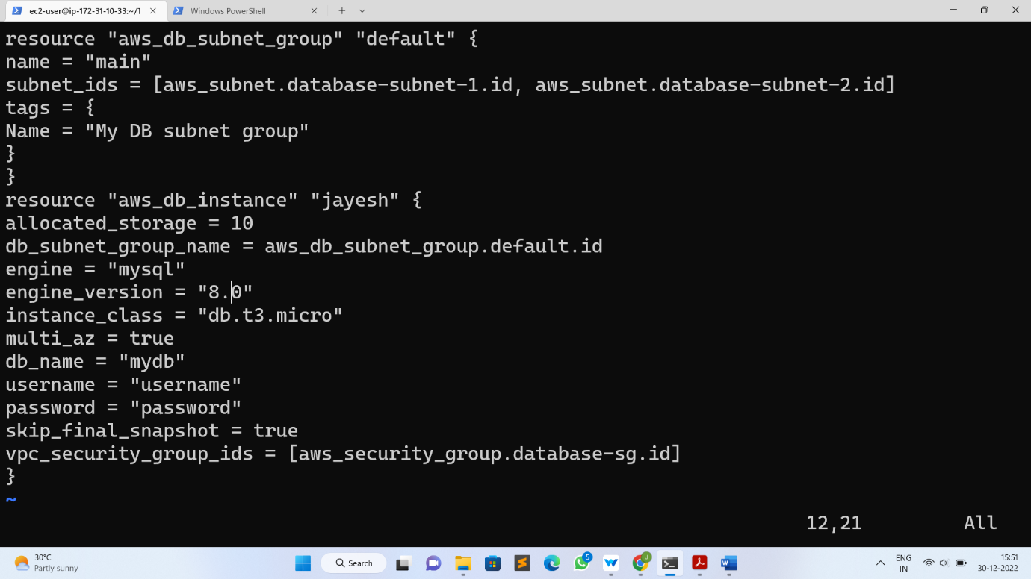

* In the above code, we need to change the value of username & password
* multi-az is set to true for the high availability

**Step 10: Create a file for outputs**

* Create outputs.tf file and add the below code to it

# Getting the DNS of load balancer

output "lb_dns_name" {

description = "The DNS name of the load balancer"

value = "${aws_lb.external-alb.dns_name}"

}

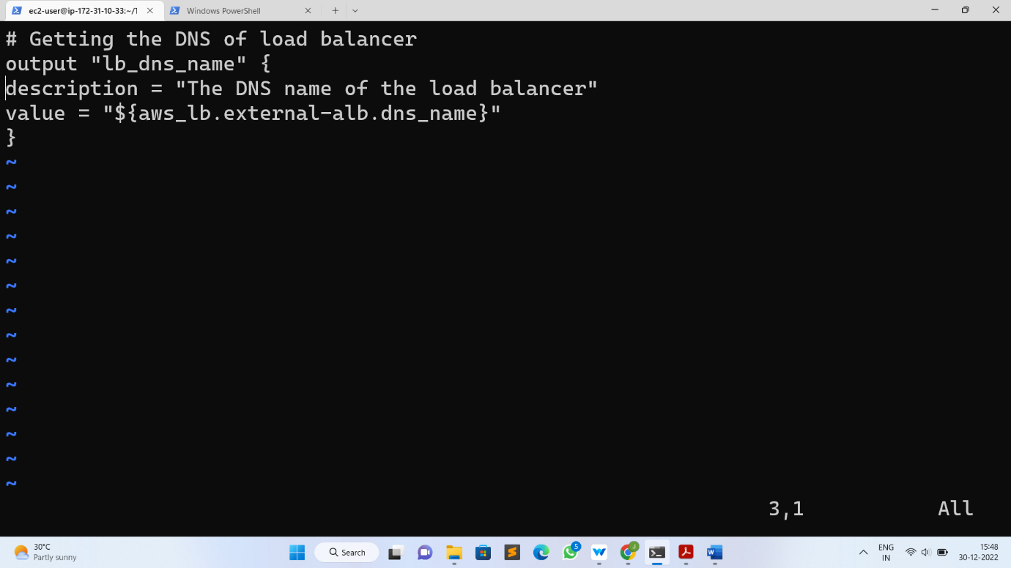

* From the above code, we will get the DNS of the application load balancer.

**Step 11: Create a file for variable**

* Create vars.tf file and add the below code to it

# Defining CIDR Block for VPC

variable "vpc_cidr" {

default = "10.0.0.0/16"

}

# Defining CIDR Block for 1st Subnet

variable "subnet_cidr" {

default = "10.0.1.0/24"

}

# Defining CIDR Block for 2nd Subnet

variable "subnet1_cidr" {

default = "10.0.2.0/24"

}

# Defining CIDR Block for 3rd Subnet

variable "subnet2_cidr" {

default = "10.0.3.0/24"

}

# Defining CIDR Block for 3rd Subnet

variable "subnet2_cidr" {

default = "10.0.4.0/24"

}

# Defining CIDR Block for 3rd Subnet

variable "subnet2_cidr" {

default = "10.0.5.0/24"

}

# Defining CIDR Block for 3rd Subnet

variable "subnet2_cidr" {

default = "10.0.6.0/24"

}

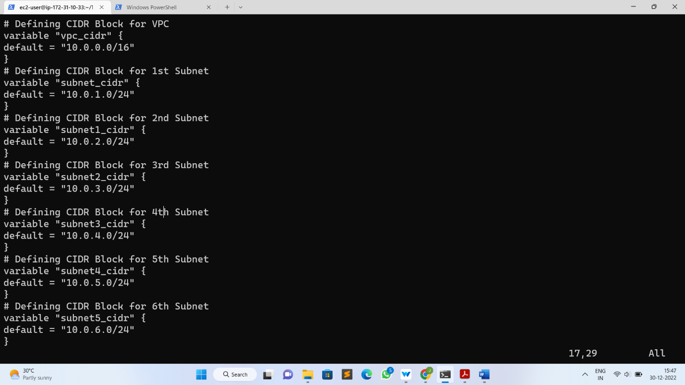

**Step 12: Create a file for user data**

* Create data.sh file and add the below code to it

#!/bin/bash

yum update -y

yum install -y httpd.x86_64

systemctl start httpd.service

systemctl enable httpd.service

echo "Hello World from $(hostname -f)" > /var/www/html/index.html

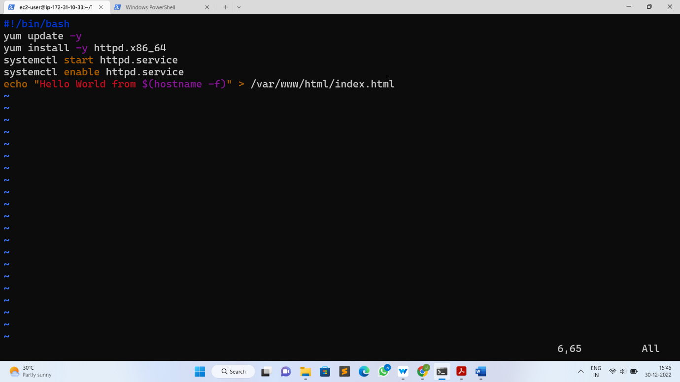

* The above code will install an Apache webserver in the EC2 instances
* After creating all the required files, you have to initialize them using below command
* terraform init

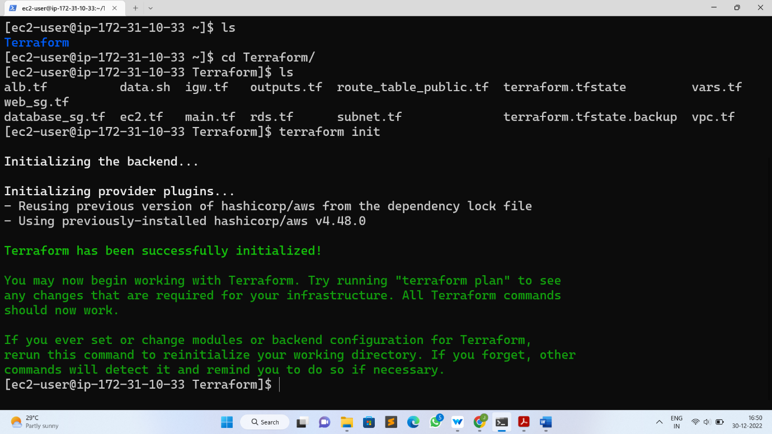

* terraform init is to initialize the working directory and downloading plugins of the provider
* Then use next command to create an execution plan for our code
* terraform plan

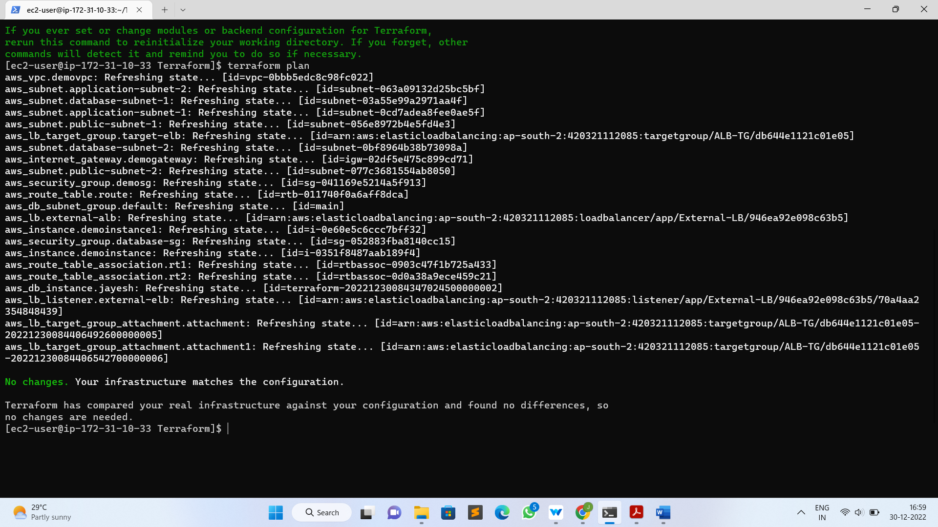

* terraform plan is to create the execution plan for our code
* Then for creating our infrastructure we have to use below command
* Terraform apply

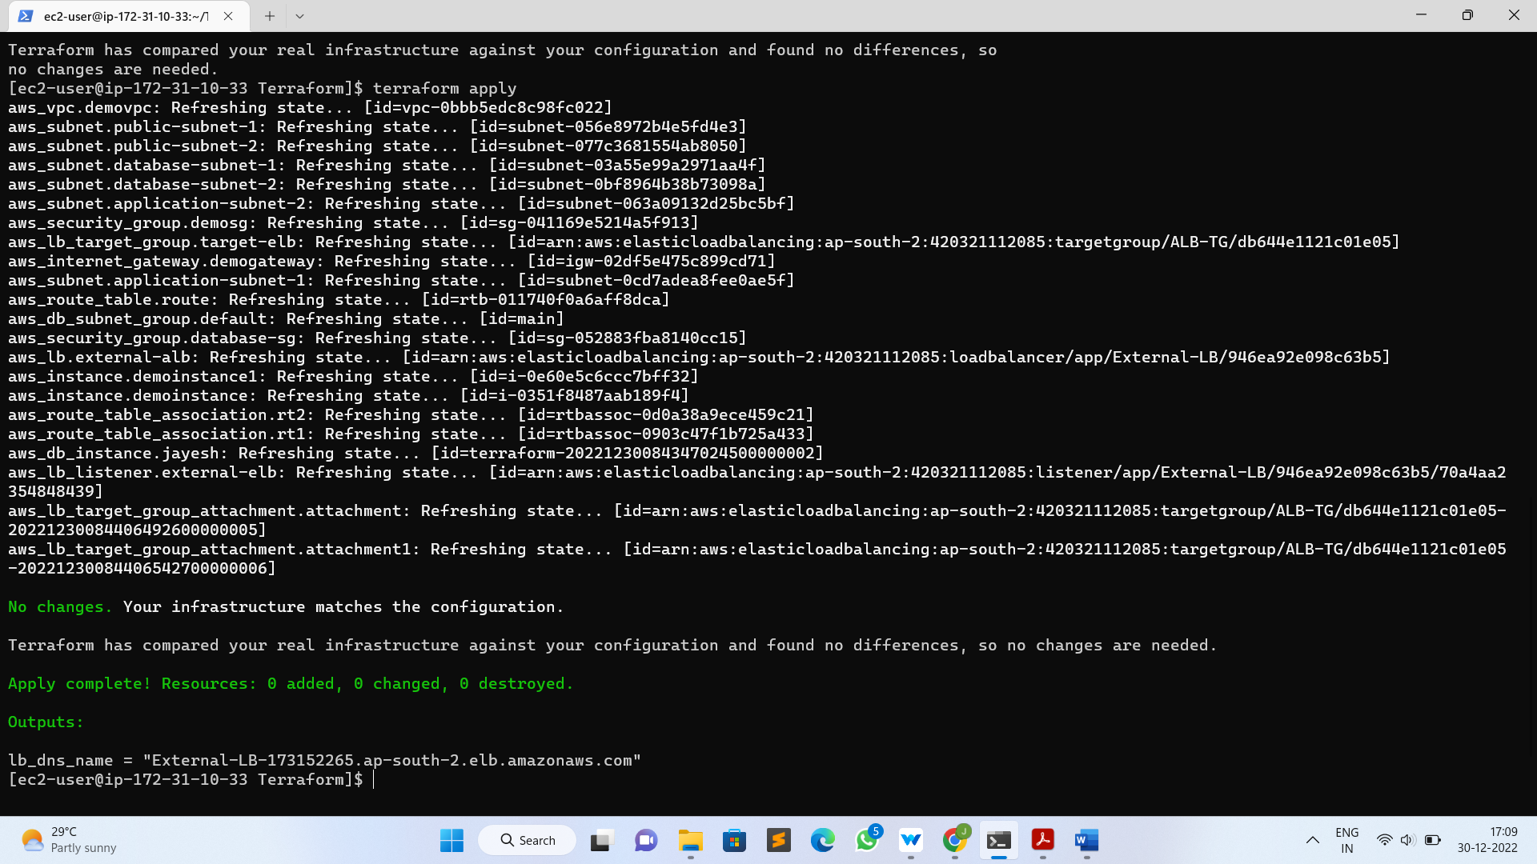

* terraform apply is to create the actual infrastructure. It will ask you to provide the Access Key and Secret Key in order to create the infrastructure. So, instead of hardcoding the Access Key and Secret Key, it is better to apply at the run time.

**Step 13: Verify the resources**

* Terraform will create below resources
* VPC
* Public & Private Subnets
* Route Tables
* Internet Gateway
* EC2 instances
* RDS instance
* Application Load Balancer
* Security Groups for Web & RDS instances

Once the resource creation finishes you can get the DNS of a load balancer and paste it into the browser and you can see load balancer will send the request to two instances.

That’s it now, we have done the project how to create various resources in AWS using Terraform.

* **Output:**
* Then copy the public domain of our instance and paste it in a browser and we will get our output.

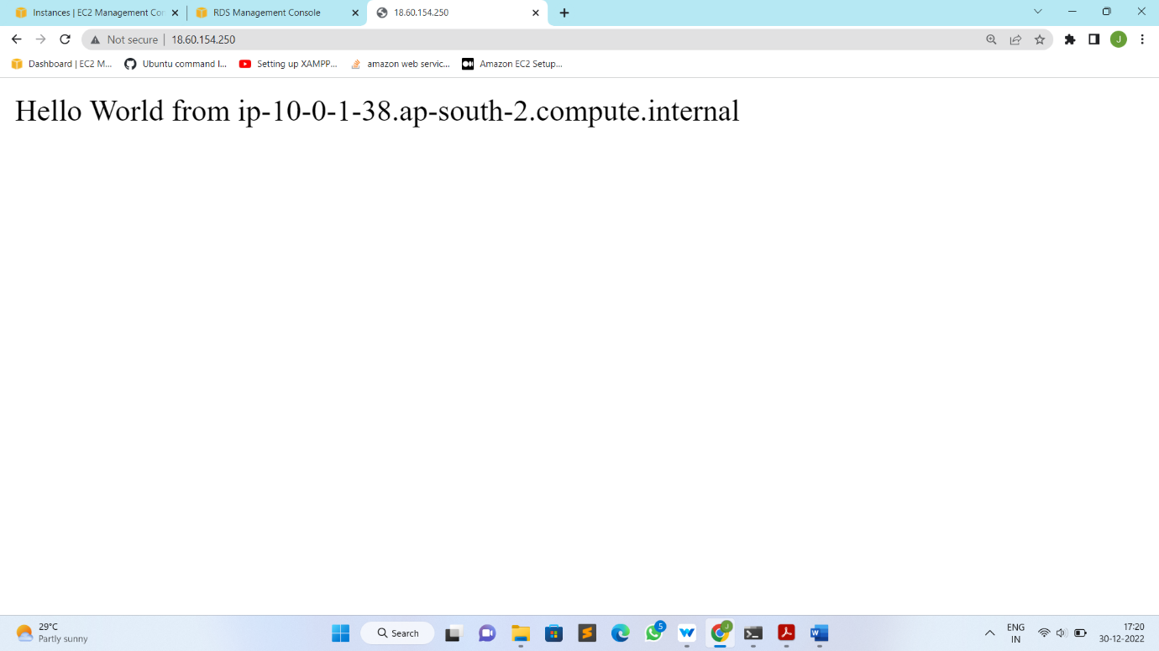

* To delete all the created infrastructure, enter the below command:
* terraform destroy